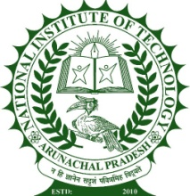
National Institute of Technology Arunachal Pradesh
Jote,Papumpare, Arunachal Pradesh-791113, India
www.nitap.ac.in
Report
About Event
The Daily Yoga Sadhana Program was successfully organized at National Institute of Technology Arunachal Pradesh from 1–21 June 2026 in connection with the observance of the 12th International Day of Yoga (IDY–2026). Conducted daily from 6:00 AM to 7:00 AM in front of the TEL Centre, Mechanical Block B-II, the program witnessed enthusiastic participation from students, faculty members, staff, and their family members. All yoga sessions were personally mentored and guided by Prof. Mohan V. Aware, Director, NIT Arunachal Pradesh, who served as the Yoga Guru and Patron of the program. Each session commenced with Guru Vandana, followed by Śarīr Sanchalan, Pad Sanchalan, and a series of yogic practices including Tadasana, Konasana, Surya Namaskar, Anand Mandir Asana, Pavanmuktasana, Setu Bandhasana, Sarvangasana, Naukasana, Dhanurasana, Bhujangasana, Paschimottanasana, along with Sukshma Vyayama. Participants also practiced Pranayama techniques such as Anulom Vilom, Bhastrika, and Kapalbhati, and each session concluded with Omkar chanting and the Shanti Mantra, fostering physical fitness, mental well-being, discipline, and inner peace. To further enrich the program, an invited lecture on “योग, योगी और सकारात्मक सोच/विचारधारा” was delivered by Prof. S. P. Singh on 14 June 2026, emphasizing the philosophy of yoga and the importance of positive thinking, while Dr. B. R. Ramakrishna delivered an inspiring lecture on “Yoga for Health, Happiness and Harmony” on 15 June 2026, highlighting the role of yoga in achieving holistic health and balanced living. On the concluding day, participants collectively watched the live telecast of the International Day of Yoga celebrations and address by Hon’ble Prime Minister Shri Narendra Modi on a large screen, reaffirming the national message of health and wellness through yoga. The program concluded with a certificate distribution ceremony, where certificates were awarded to all active participants in recognition of their dedication and regular participation throughout the 21-day event. The program successfully promoted the values of yoga, healthy living, positivity, and social harmony, inspiring participants to adopt yoga as an integral part of their daily lives.

Brief About the Yoga guru/Keynote Speaker
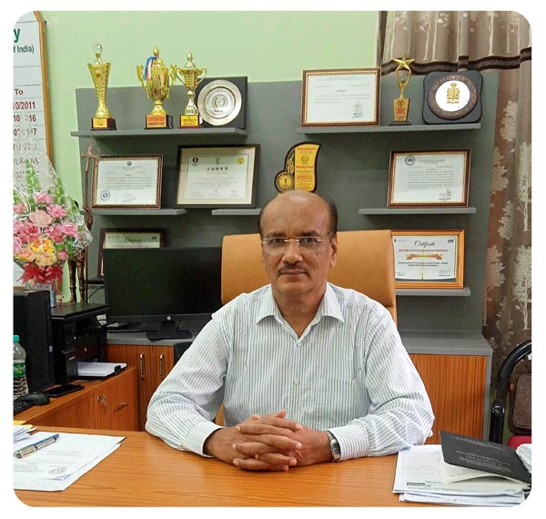 | Prof. Mohan V Aware  Yoga Guru and Patron  Director, NIT Arunachal Pradesh
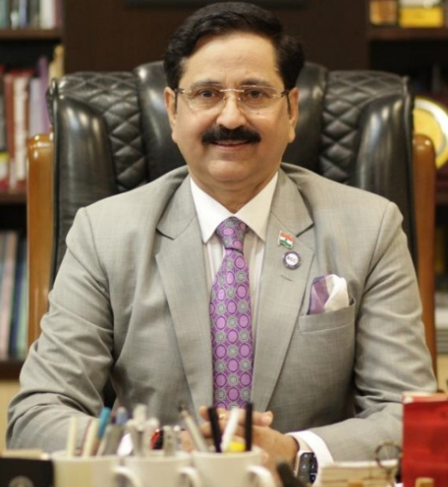 | Prof. (Dr.) S. P. Singh  Director General (Vice Chancellor)  Kaushalya - The Skill University  Government of Gujarat
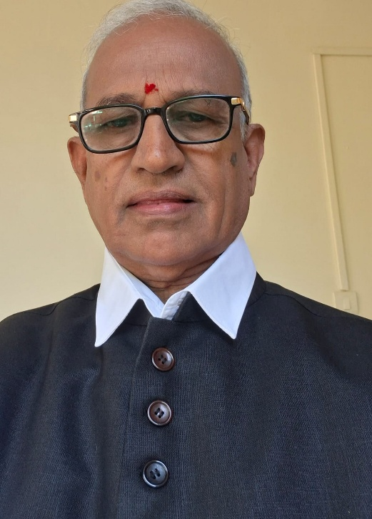 | Dr B R Ramakrishna  BSAM, BAMS, MD (Ayu), MSc & PhD (Yoga).  Pro-Chancellor, Swamy Vivekananda Yoga Anusandhana Samsthana (S-VYASA), Prashanthi Kuteeram, Jodibingipura, Jigani, Anekal Taluk, Bangalore-560105,

Participants Details
Approximately 20 participants attended the Daily Yoga Sadhana Program each day, comprising students, faculty, staff, and residents of NIT Arunachal Pradesh, along with yoga enthusiasts from nearby local communities.
Outcomes
The Daily Yoga Sadhana Programme successfully enhanced awareness regarding the significance of yoga for holistic health and well-being among participants. Regular practice of yoga and pranayama improved physical fitness, flexibility, concentration, stress management, and emotional balance, while fostering discipline, positivity, and healthy lifestyle habits. The programme also strengthened community engagement by bringing together participants from within and outside the institute, inspiring them to incorporate yoga into their daily lives for sustained health, happiness, and harmony.
Photos Gallery

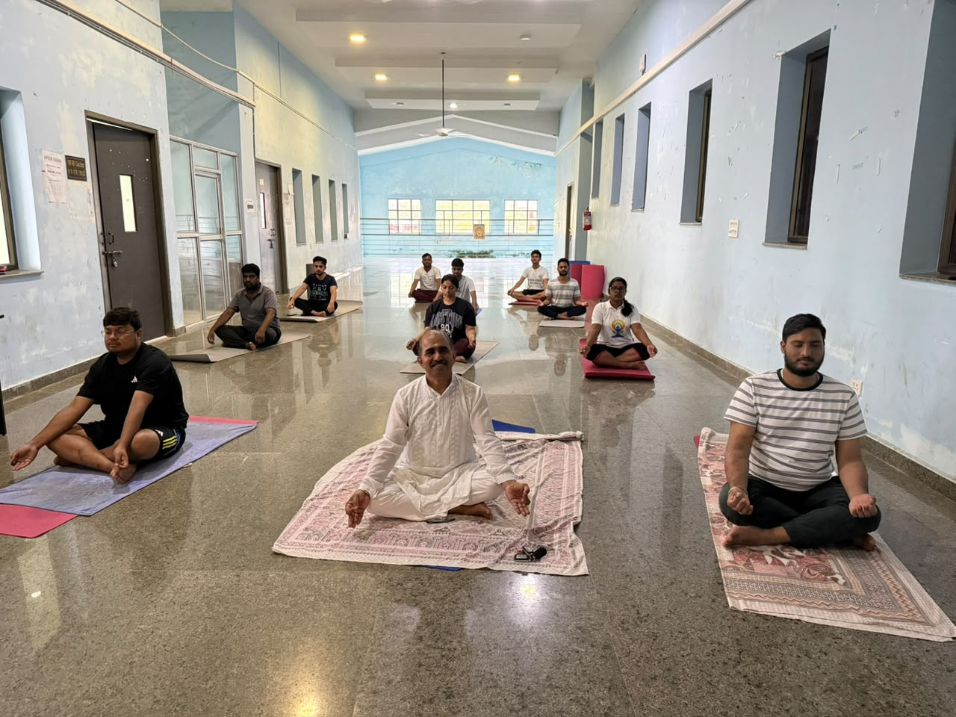
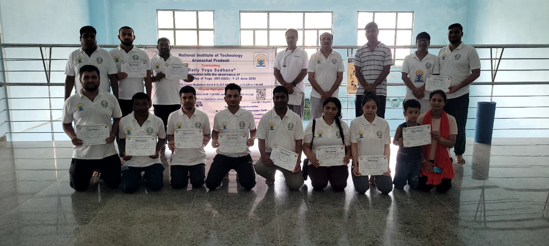
Participants, organizers, after certificate distributions

